Java Programming by CodeAcademy

Sun Microsystems released the Java programming language in 1995. Java is known for being simple, portable, secure, and robust. Though it was released over twenty years ago, Java remains one of the most popular programming languages today.
One reason people love Java is the Java Virtual Machine, which ensures the same Java code can be run on different operating systems and platforms. Sun Microsystems’ slogan for Java was “write once, run everywhere”.
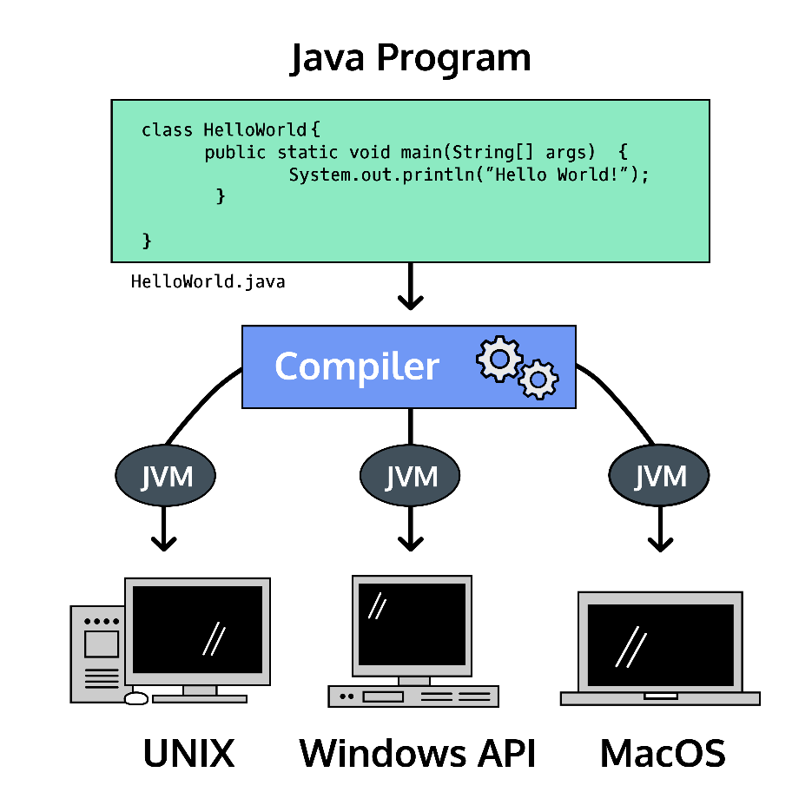

Compiling Java
In Java, when we compile a program, each individual class is converted into a .class file, which is known as byte code.
The JVM (Java virtual machine) is used to run the byte code.
# Compile the class file:
javac hello.java

# Execute the compiled file:
java hello

🧠

What Happens When You Compile Java?
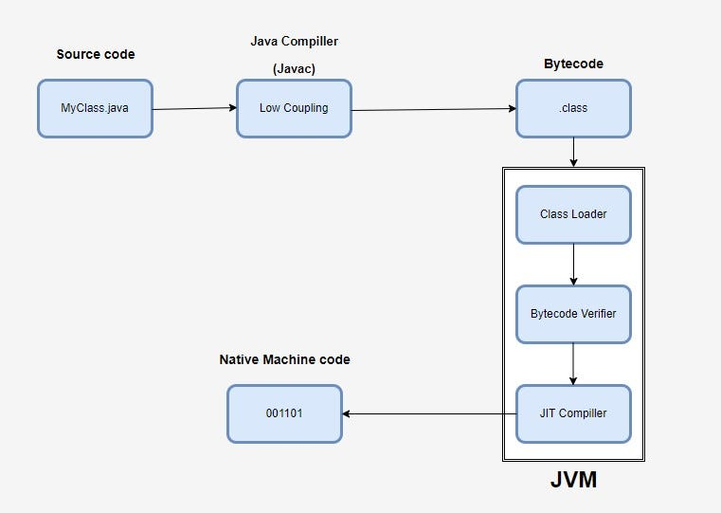
What is javac?
javac (pronounced "java-see") is the primary Java compiler included in the Java Development Kit (JDK) from Oracle Corporation.

What javac Does:
- It reads Hello.java
- It checks for syntax errors
- It converts it into bytecode
- It creates a file:
Hello.class
This .class file contains bytecode, not machine code.
- The above code is Java source code (.java file).
- The Java compiler converts it into byte code (.class file).
- The JVM executes the byte code and produces the output.

Use the link to learn more about bytecode:
https://www.geeksforgeeks.org/java/byte-code-in-java/
Trying to understanding the upper concept :
Java is called a hybrid language because it uses both compilation and interpretation:
🔹 Compilation 🏗️
Java source code (.java) is compiled into bytecode (.class) by the Java compiler.
🔹 Interpretation / Execution ⚙️
The JVM reads this bytecode and executes it (using interpretation and JIT compilation) into Machine code.
So Java gets the portability of interpretation 🌍 and the performance benefits of compilation 🚀 — that’s why it’s called hybrid.

